Name: Nishit Shaileshbhai Rathod  
Student Number: N01586439  
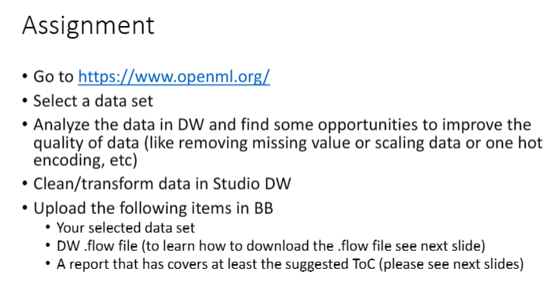

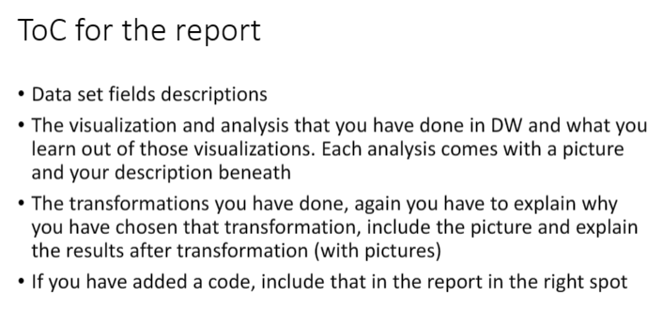

**Step 1: Selected the dataset from :** [**OpenML**](https://www.openml.org/search?type=data&status=active&qualities.NumberOfFeatures=lte_10&qualities.NumberOfClasses=lte_1&id=214)

**Step 2: Knowing the dataset.**

**The dataset is called “baskball” which has 96 instances and 5 features. The dataset was originally taken from –**

* Dataset from Smoothing Methods in Statistics (ftp stat.cmu.edu/datasets)
* Simonoff, J.S. (1996). Smoothing Methods in Statistics. New York: Springer-Verlag.

**Data Features:**

1. **points_per_minute (Target Variable) – Numeric type - 95 distinct values and 0 missing attributes.**
2. **assists_per_minute – Numeric Type - 96 distinct values and 0 missing attributes.**
3. **height – Numeric Type - 13 distinct values and 0 missing attributes.**
4. **time_played – Numeric Type - 94 distinct values and 0 missing attributes.**
5. **age – Numeric Type - 15 distinct values and 0 missing attributes.**

As the dataset didn’t have Categorical feature as well as any missing values, I deliberately transformed the dataset and added “Sex” column as well as removed some of the values from the features. By doing this I can know have the hands-on practice in data pre-processing as well as in exploratory data analysis using AWS Sage maker Data Wrangler.

**Step 3: Making the Domain, Creating the user in order to get excess to Studio.**

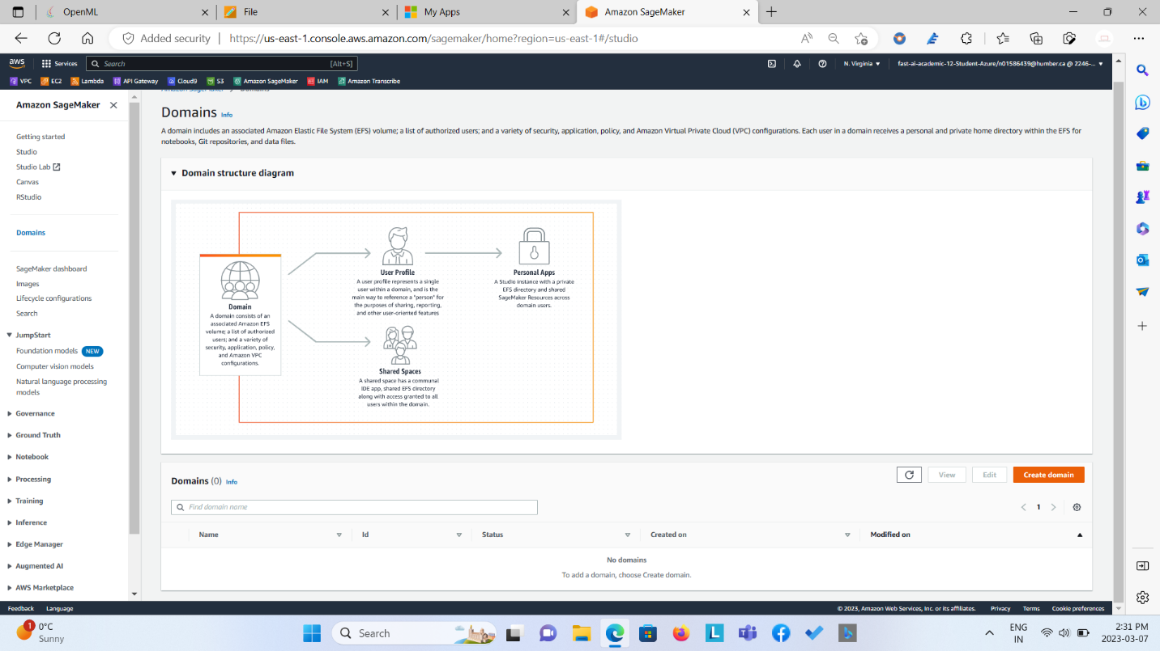

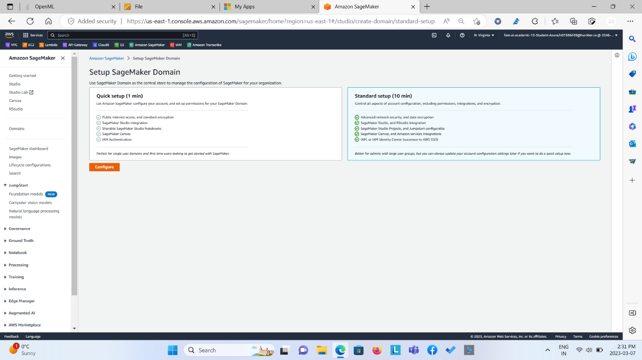

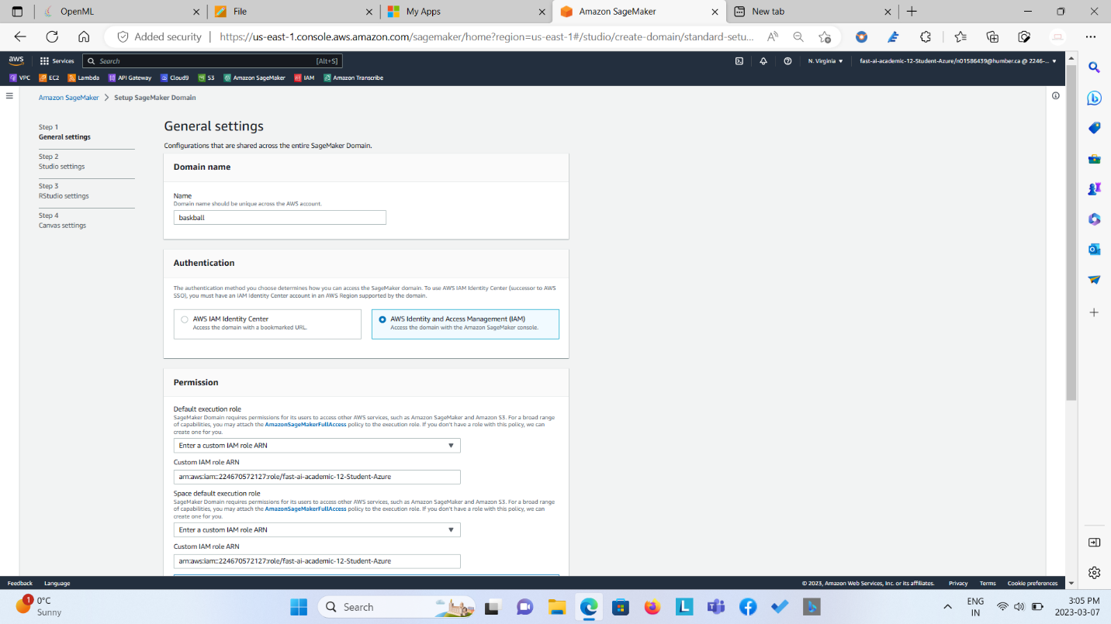

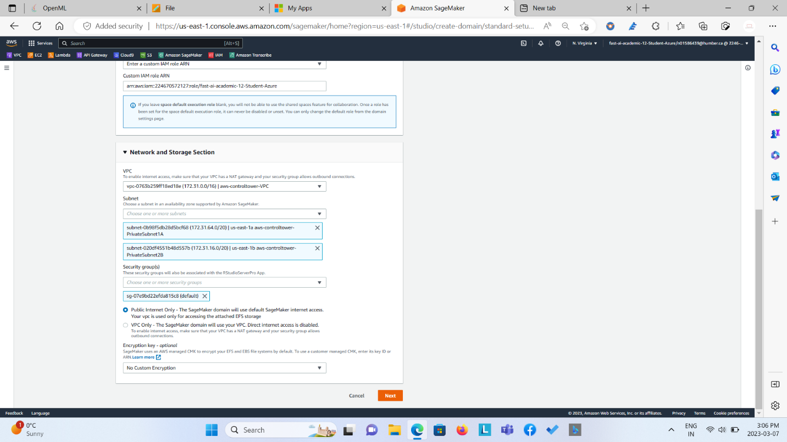

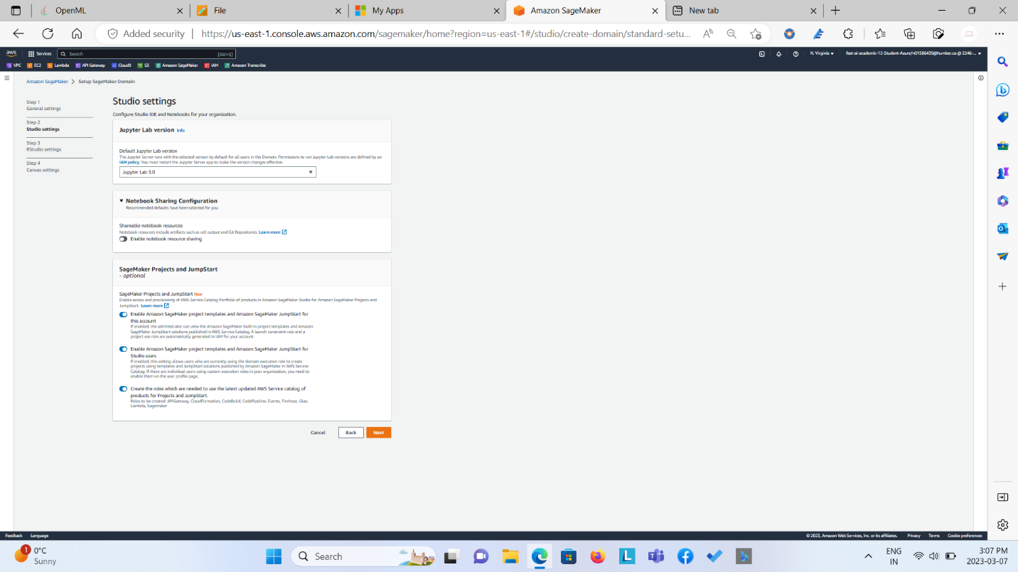

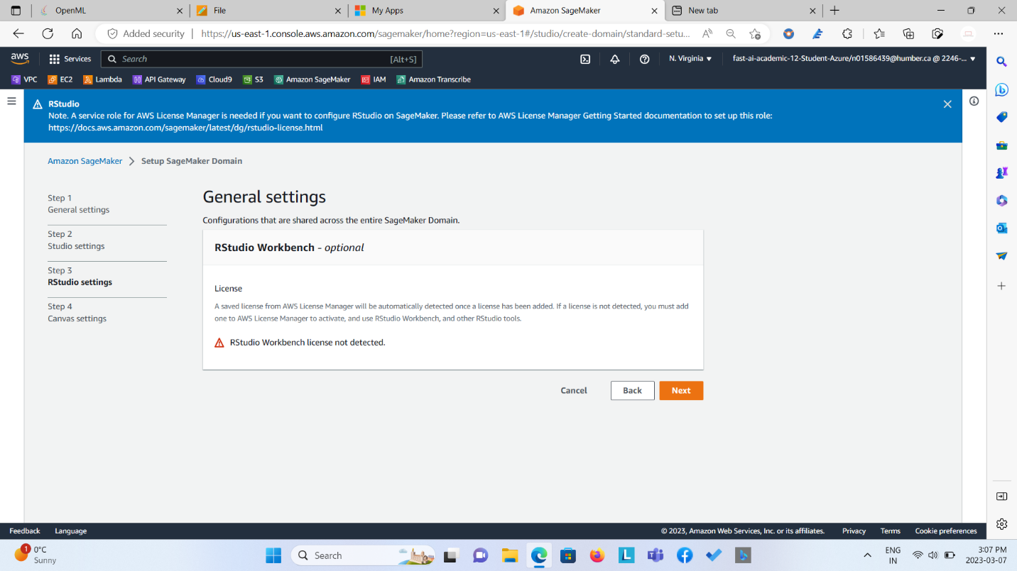

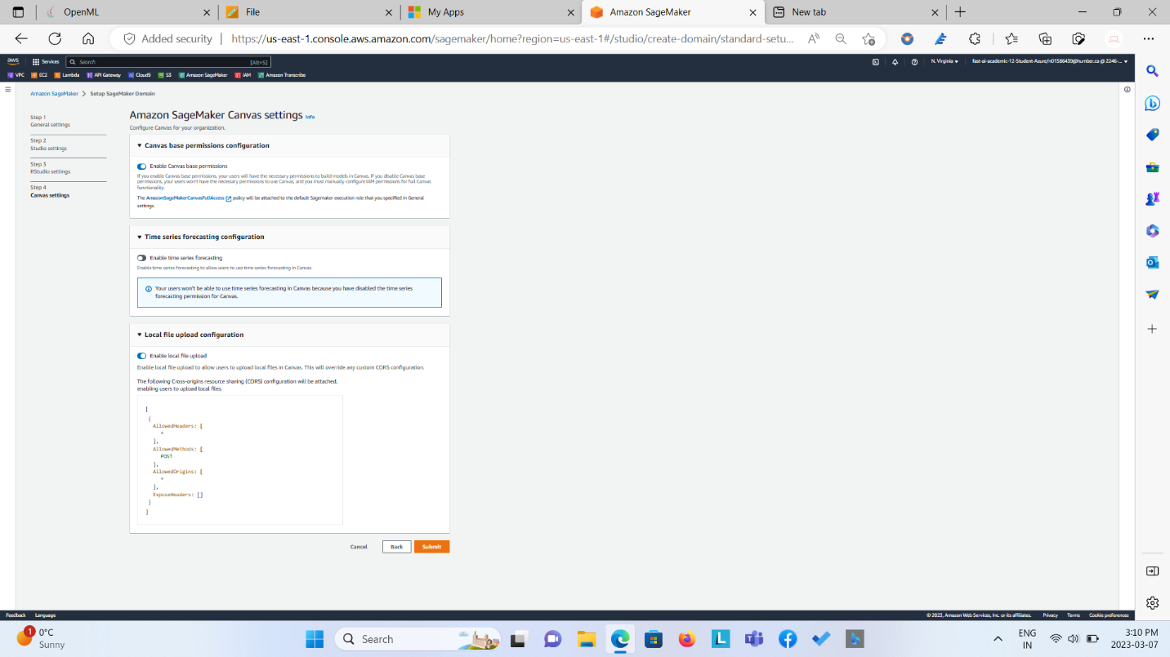

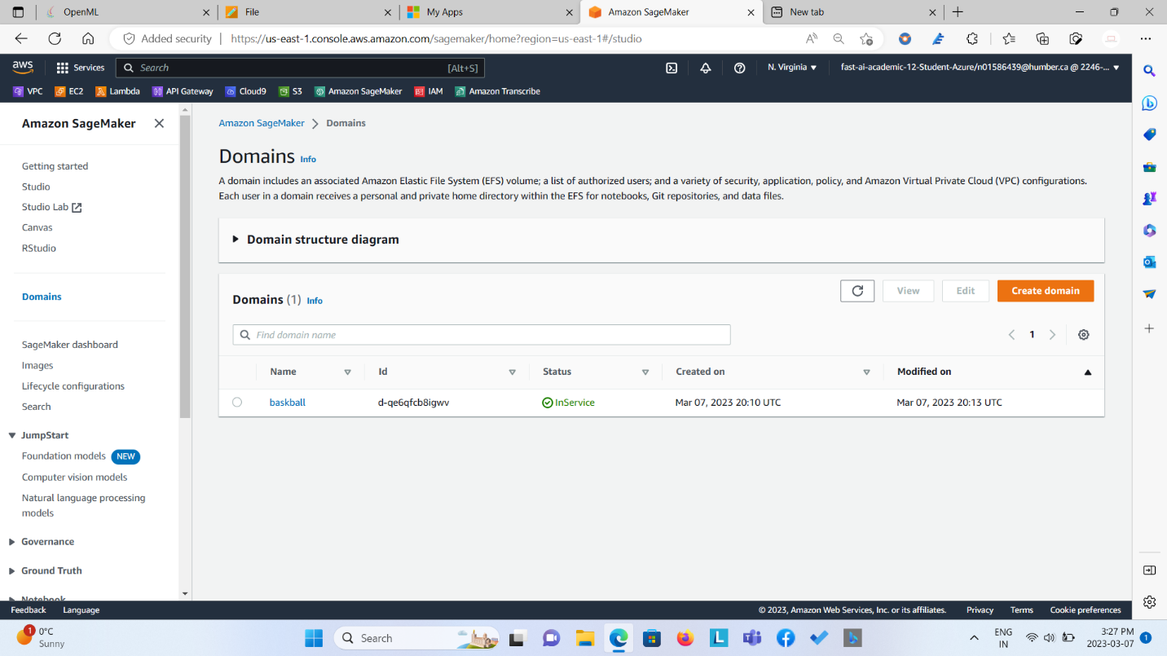

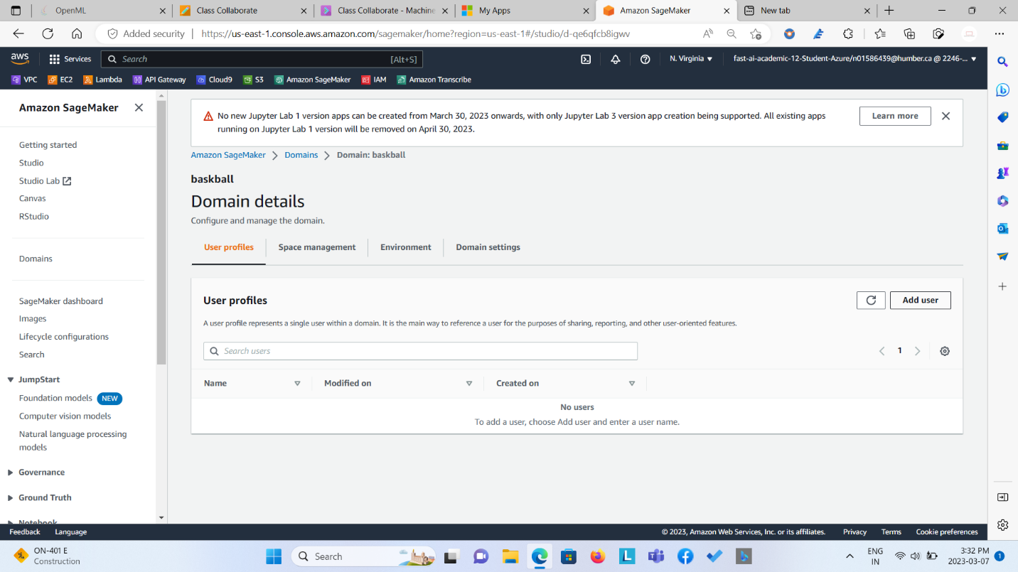

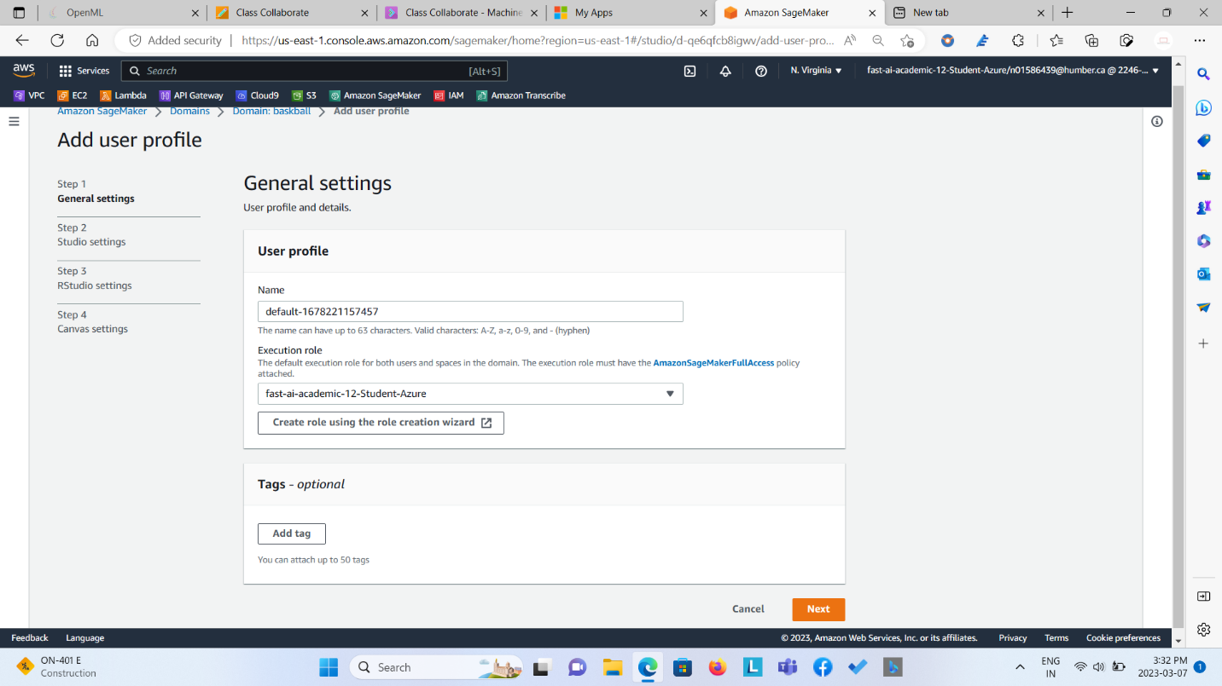

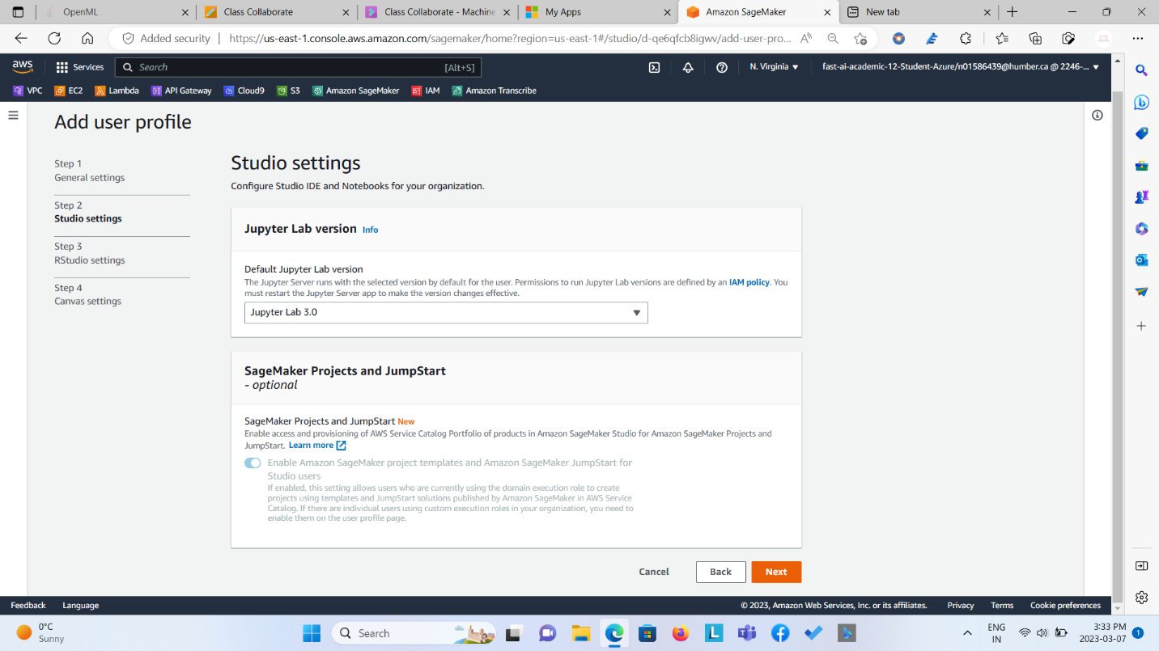

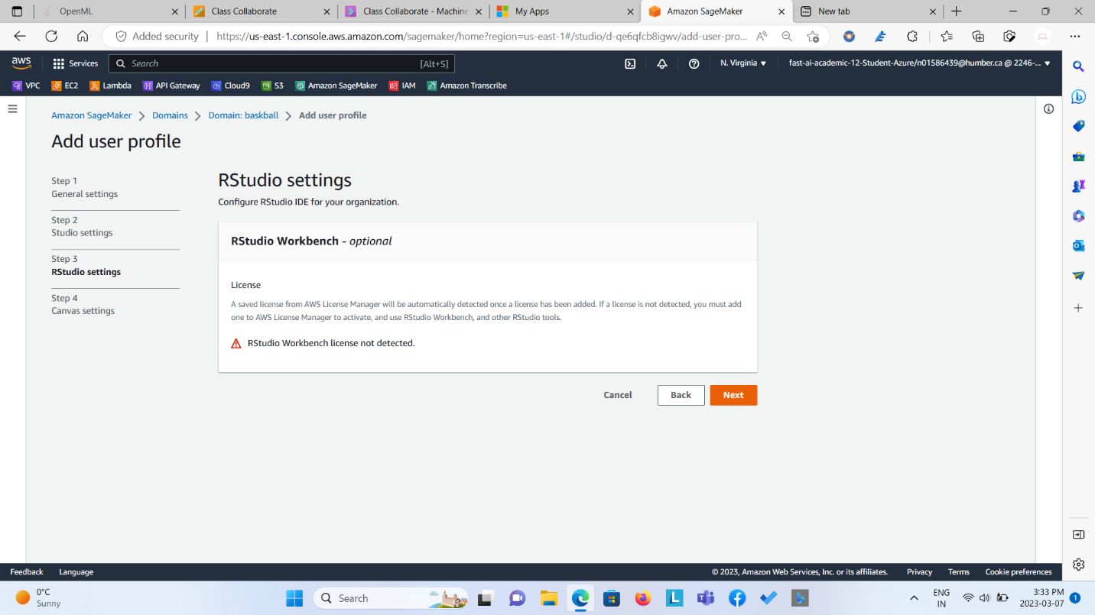

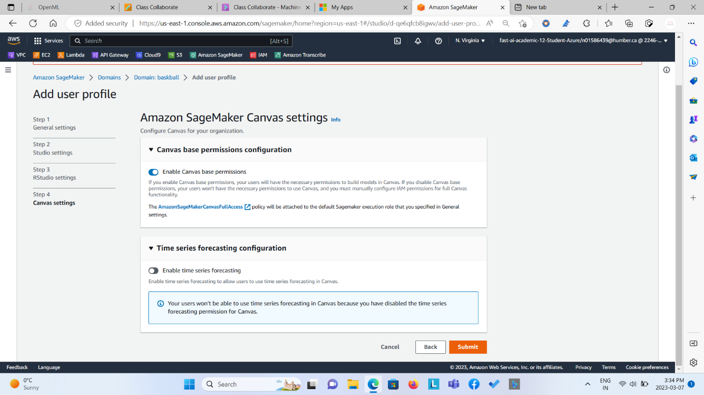

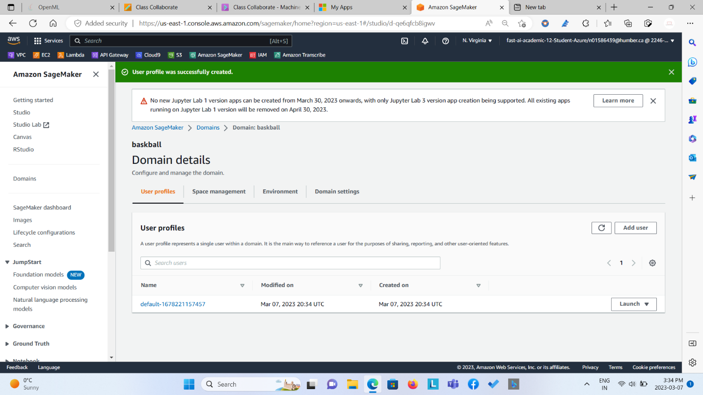

**Step 4: Creating S3 Bucket and Uploading the dataset (.csv file) in it.**

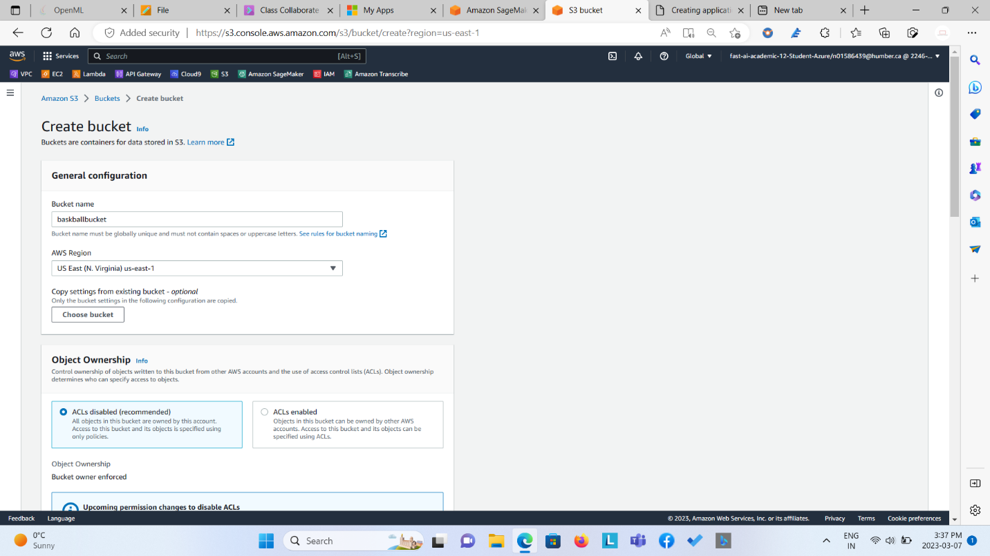

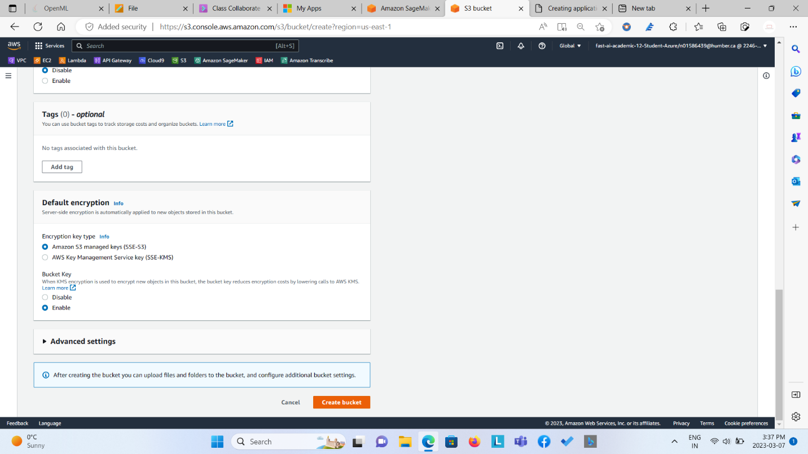

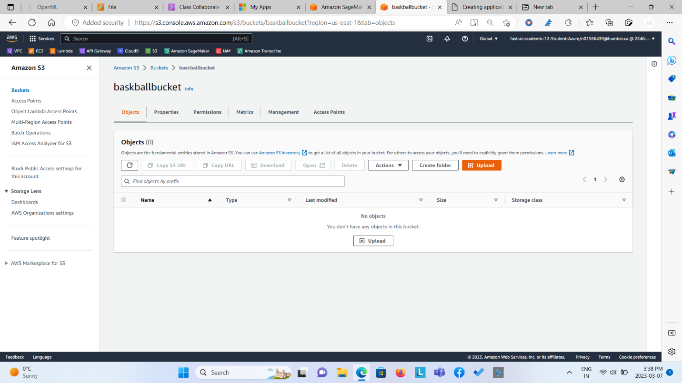

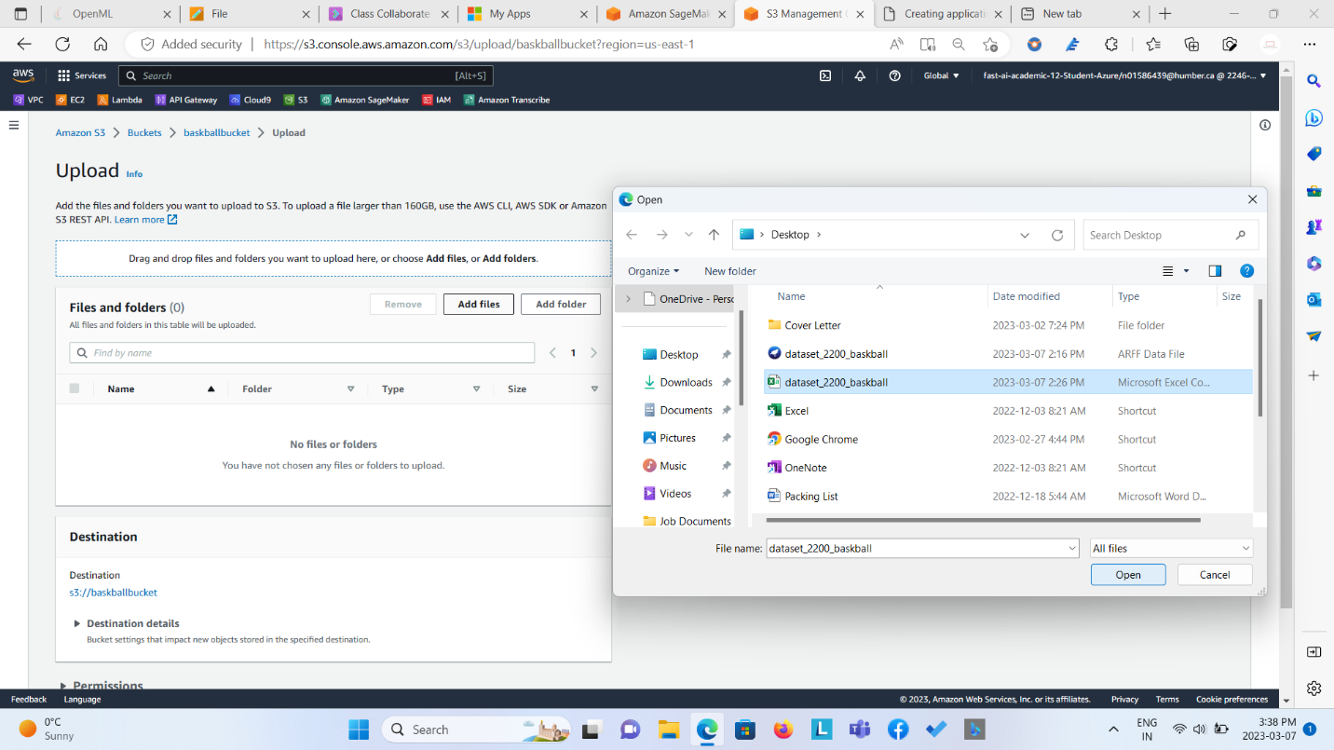

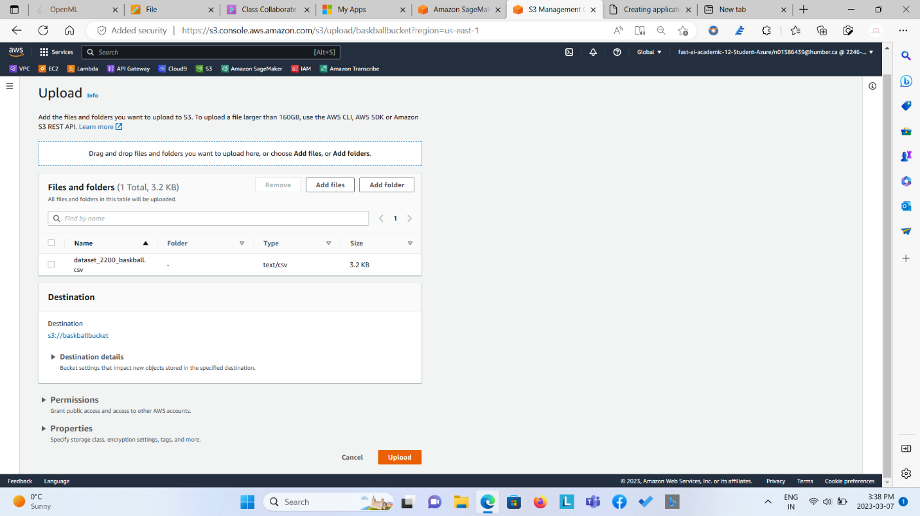

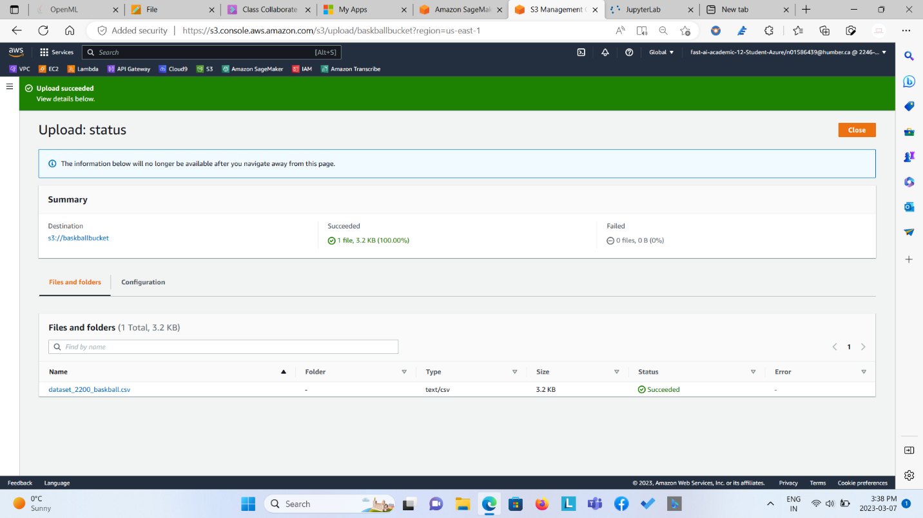

**Step 5: Performing Data Cleaning/Data Pre-processing/Data Transformation/Data Analysis via. Data Wrangler from Studio by linking Dataset from S3 Bucket.**

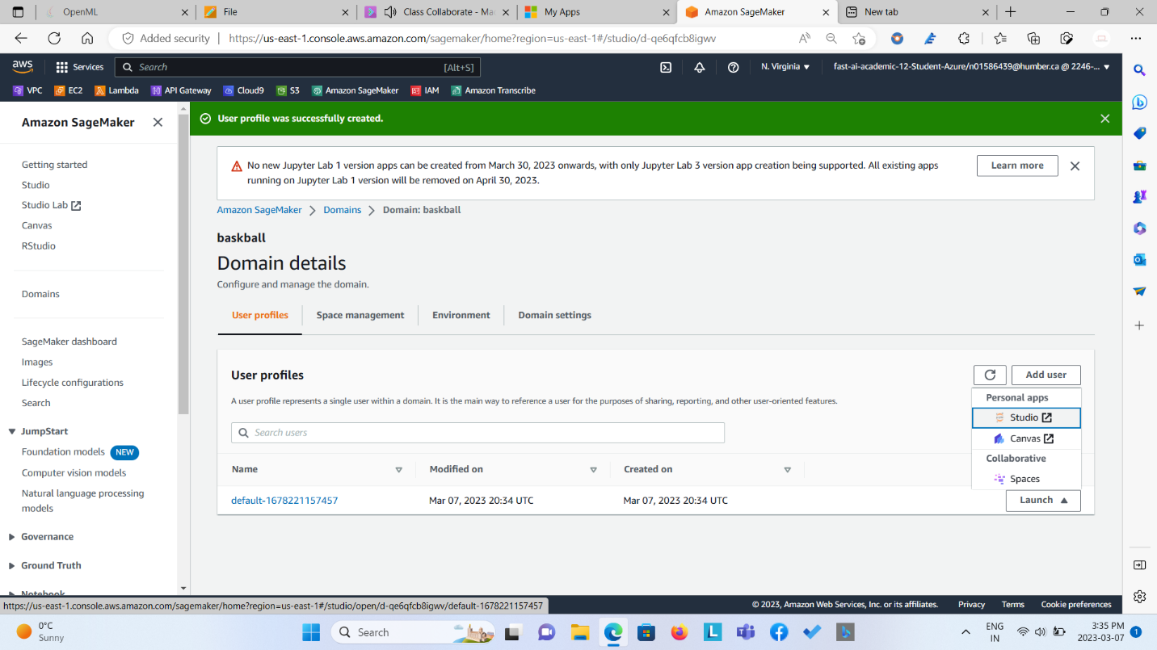

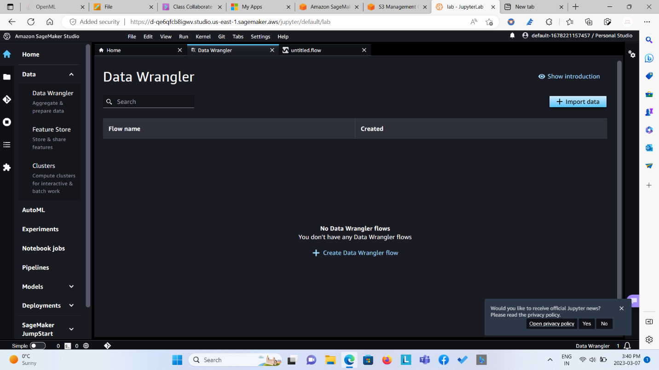

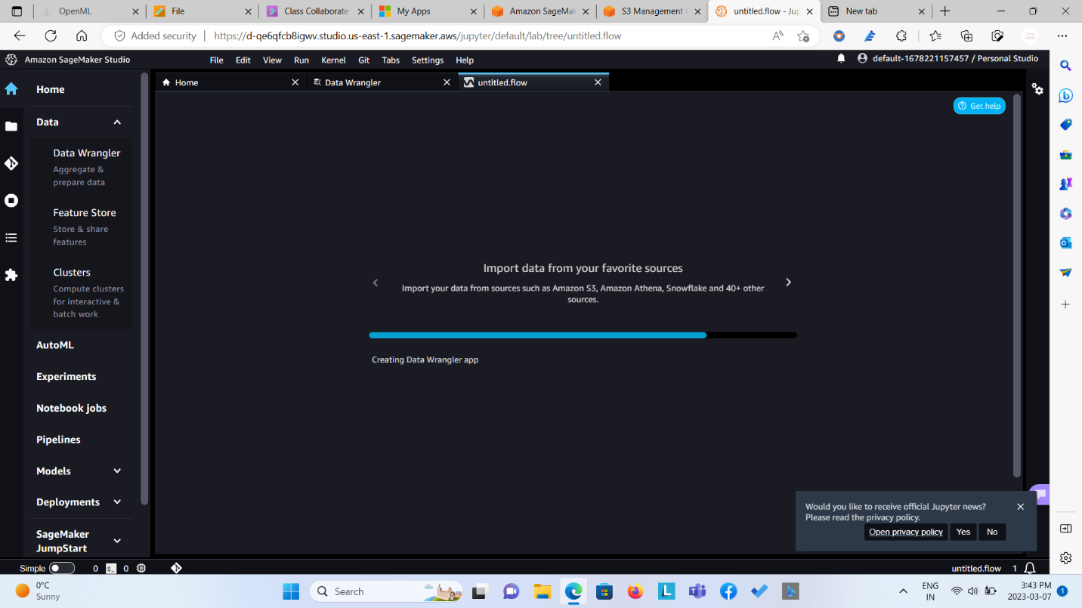

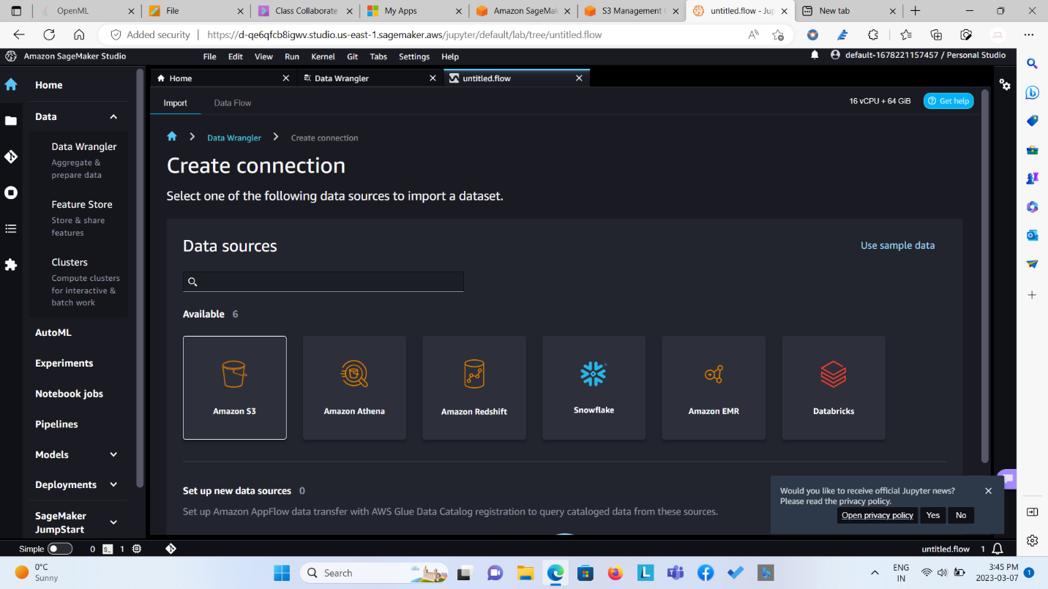

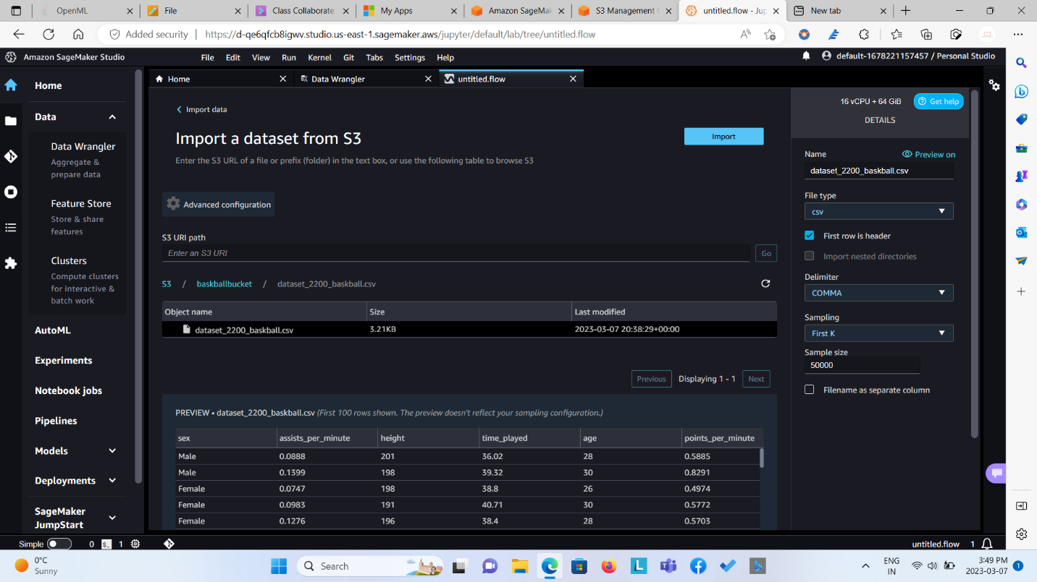

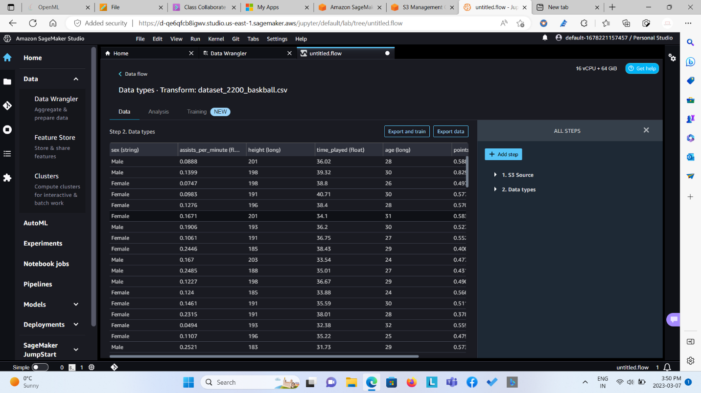

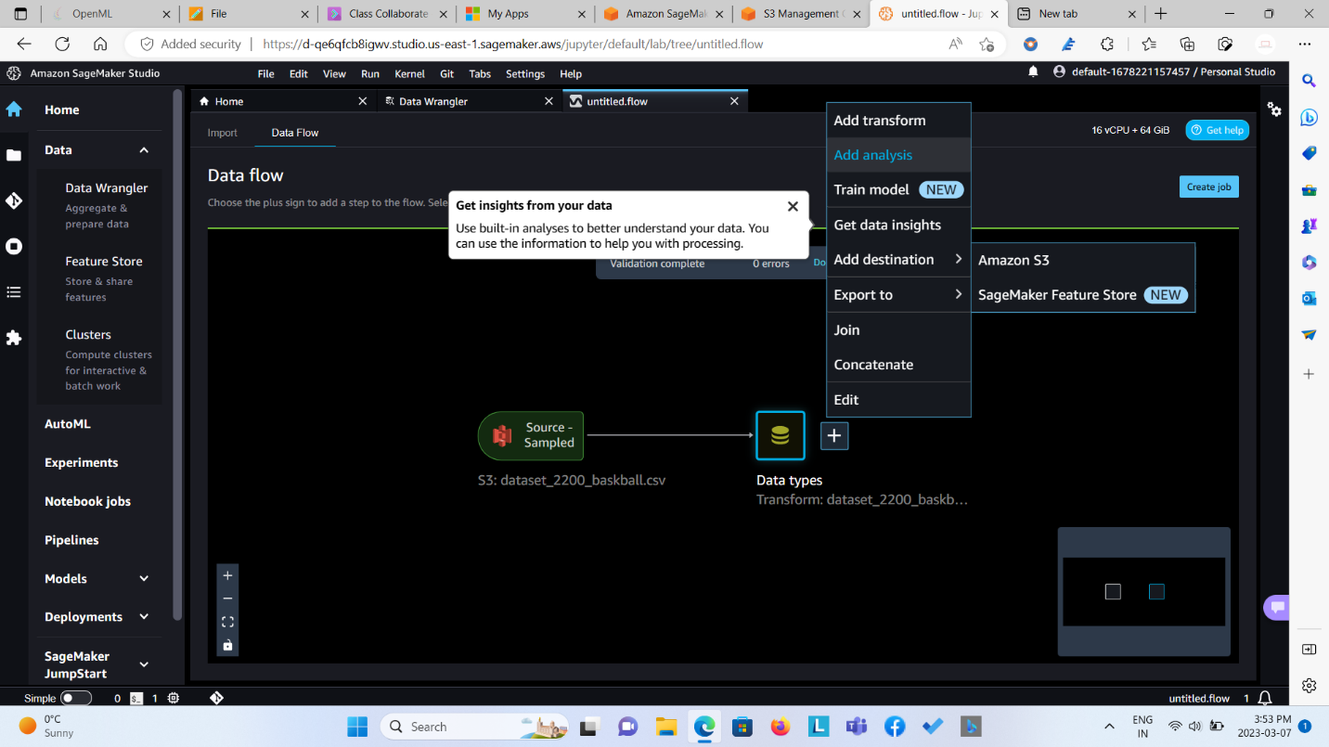

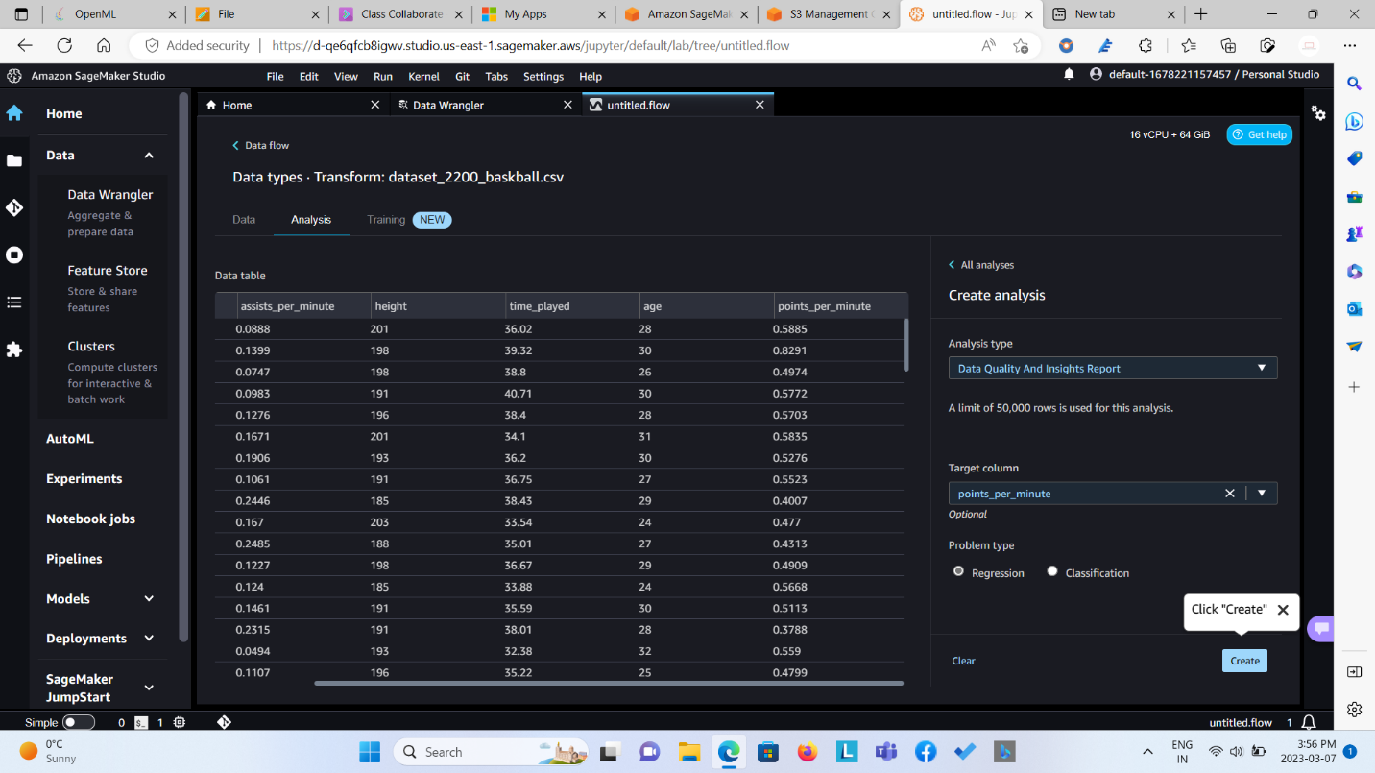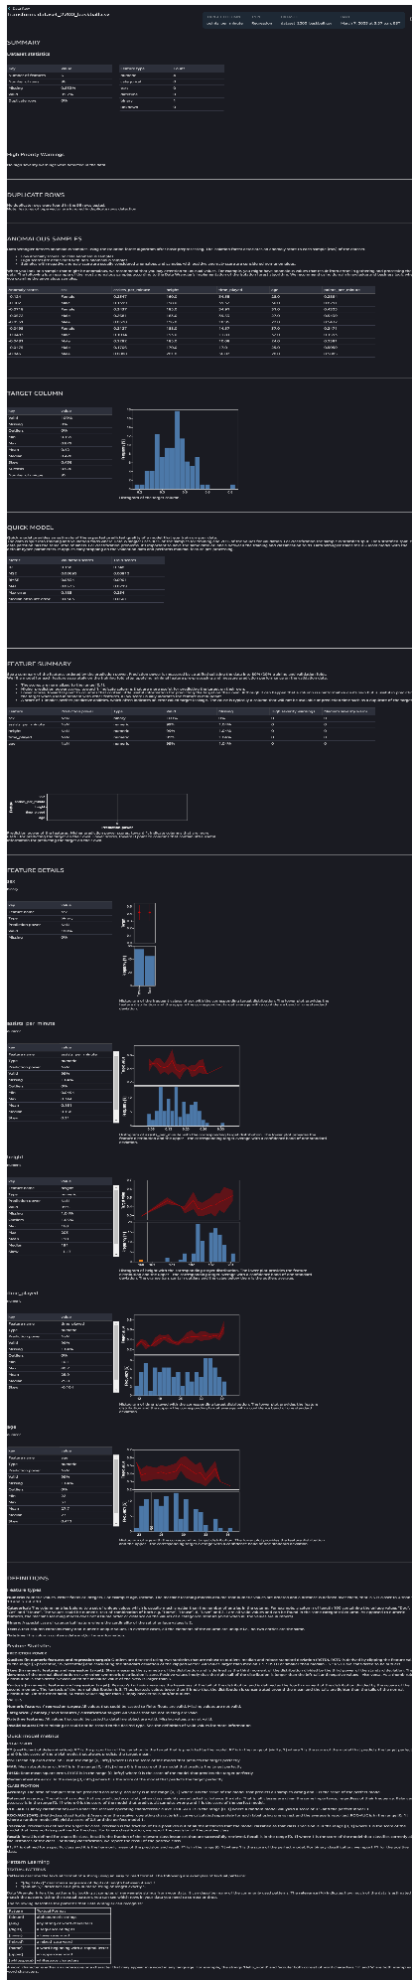

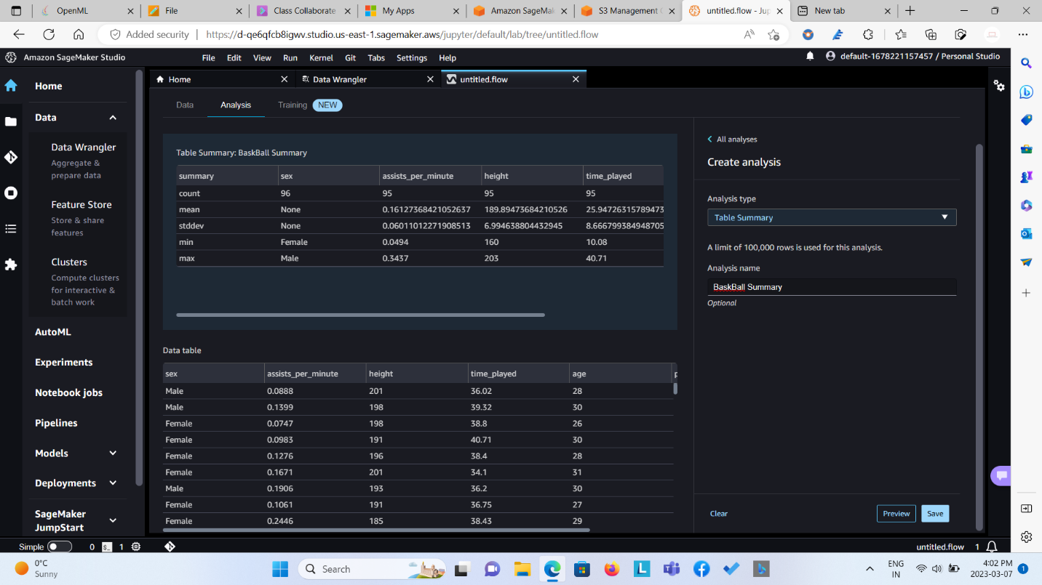

**From the data analysis report I came to know about various things –**

1. **The overview of the dataset in term for number of instances, number of features, missing data percentage, duplicate rows, data types in short all about the statistic of the dataset.**
2. **The descriptive summary of all the features in terms of min, max, mean, median, standard deviation, mode.**
3. **Summary and Distribution of the target variable as well as other features..**
4. **Quick overview about the regression model in terms of Validation scores and Test scores having R2, MSE, RMSE, MAE, Max Error, and Median Absolutely error as its metrics.**
5. **Machine Learning Terminologies**

**This was report was necessary to generate as from it we could know about the dataset which we will be working upon as well as we would get clear idea about the features and domain we are working for.**

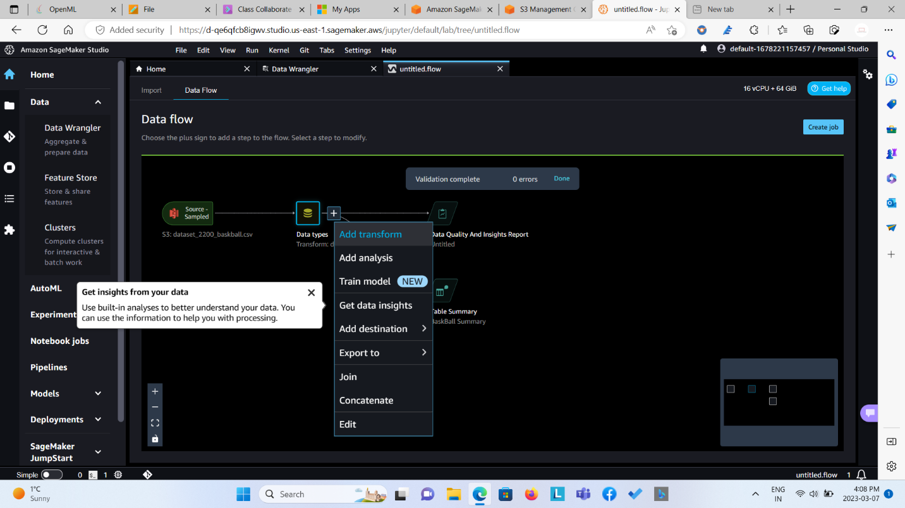

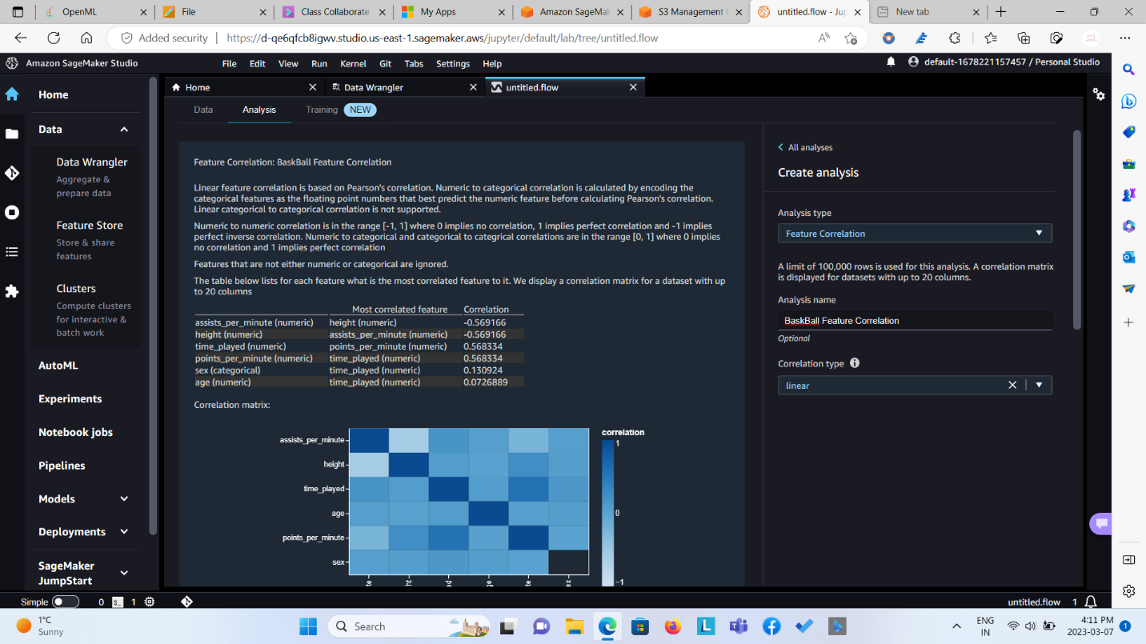

**From the above heatmap, it is inferred that there is partial correlation between features which says that the features have partial significance over the target variable in order to predict the “points scored in a minute”.**

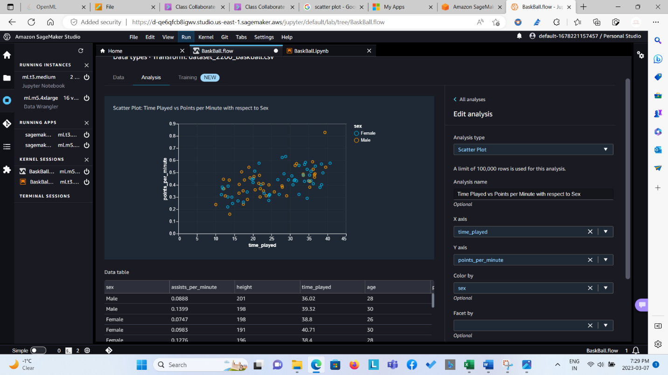

**From the above scatter diagram, it is said the there is a relationship between time played and points per minute. It shows positive correlation and it plays vital role in predicting the points scored in a minute.**

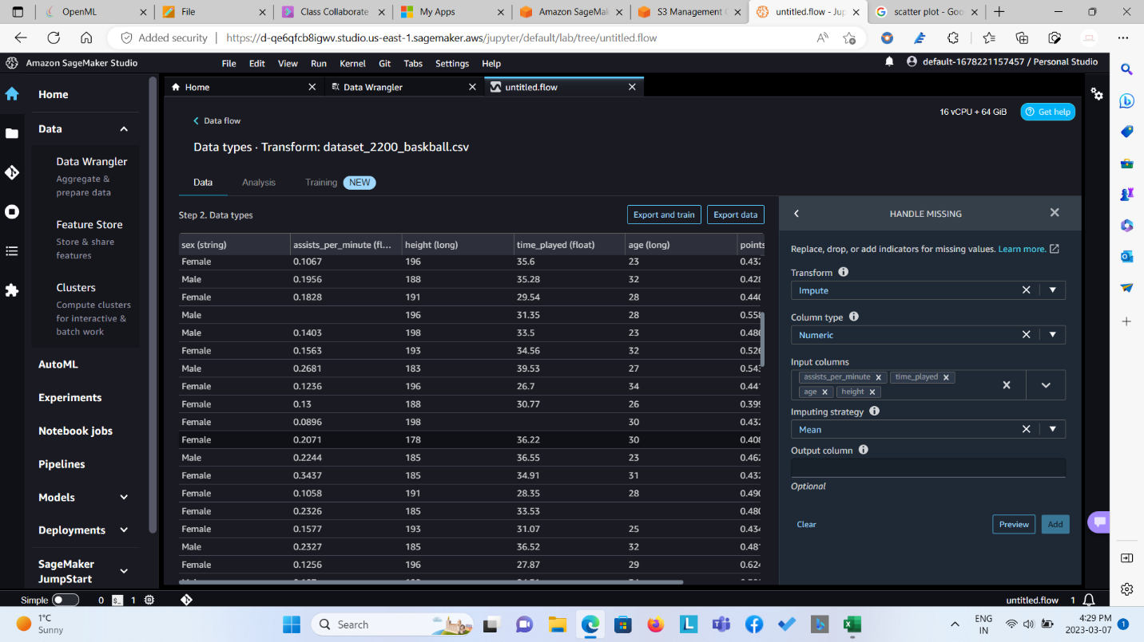

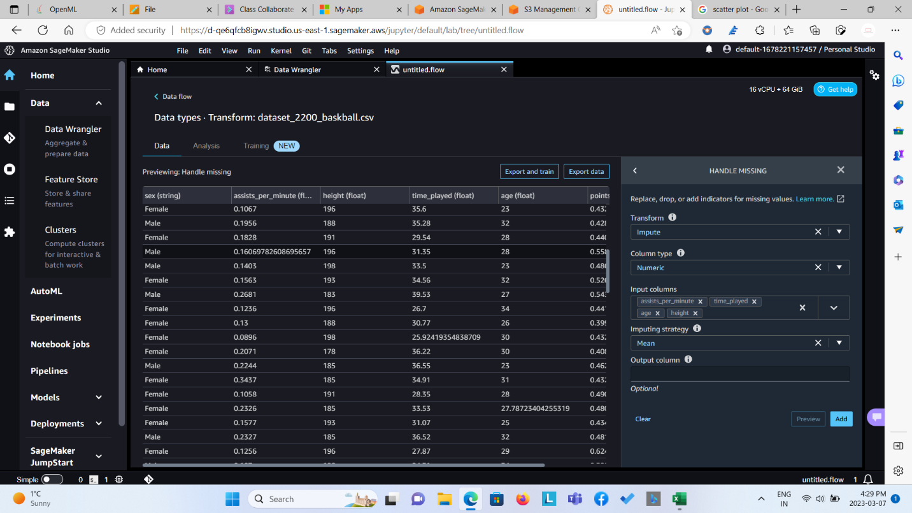

**From the above data pre-processing step, we have replaced the missing values with the mean of the particular column. We did this so that we have a complete structured dataset in order to get the desire results in terms of accuracy and precision.**

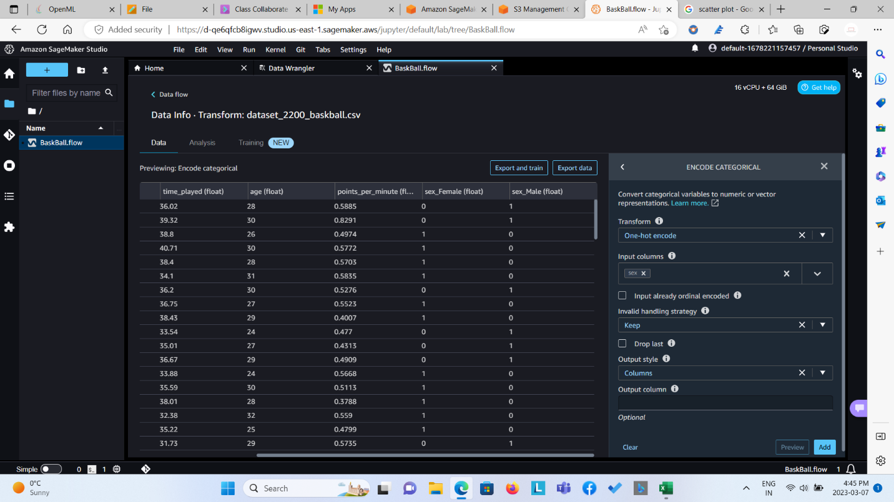

**The step for one-hot-encoding is necessary for feature named “sex”, as we know that regression model can only be applied upon the features that are quantitative in nature. Here sex is categorical variable, which also plays vital role in the prediction so to satisfy the regression condition we are converting it into numerical by encoding it as 0 and 1.**

**Step 6: Adding the Destination so that we can let the data flow to execute and the result to save into S3 bucket.**

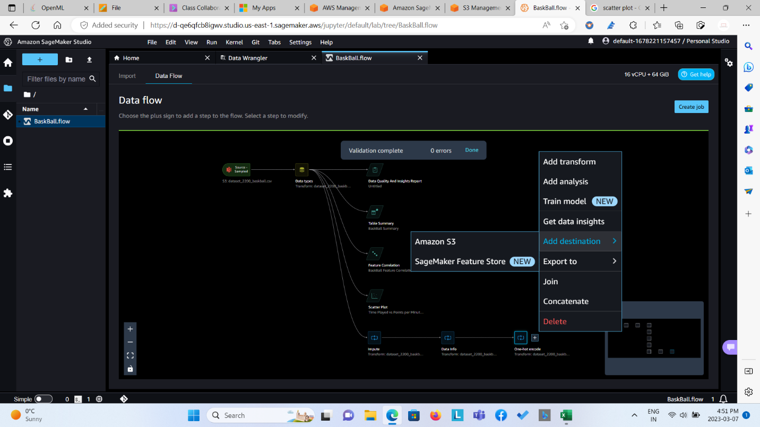

**The Final Data-Flow**

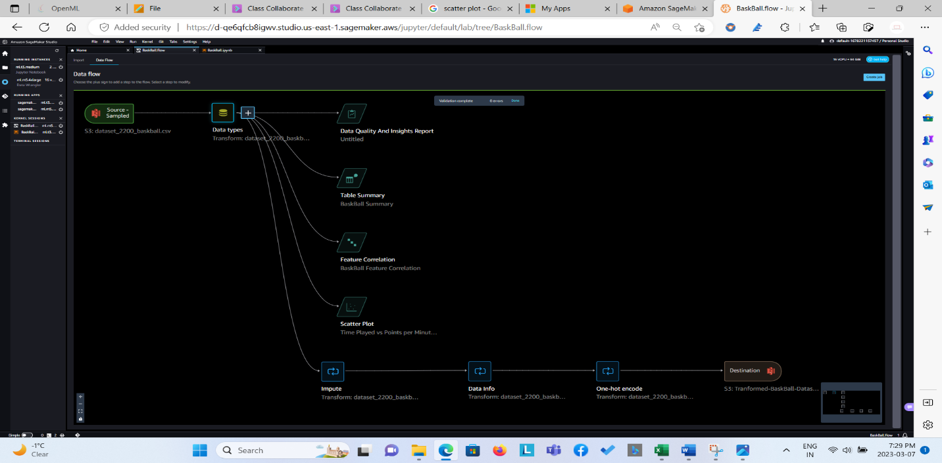

**Later, created the job and the output was exported to the s3 bucket from data wrangler/data flow.**